Beyond the Box GA is a campaign organized by community stakeholders, organizations, formerly incarcerated leaders, university students and faculty members who are invested in bridging the education gap for the 4.2 million Georgians with a criminal record.

Our Mission is to educate the public on how college applications ask if someone has been convicted of a crime and how it is a discriminatory practice. Also, to influence policy at the university and legislators level that is targeted to remove that question and create a more inclusive university admissions process.

Our Vision is that all people, no matter what their criminal convictions will be able to have equal access to educational opportunities that exist here in the state of Georgia.

What is the Box that we are trying to go Beyond? The box refers to the question that is asked on university applications on whether or not someone has been convicted of a crime.

If we banned the box, what would it affect?
Reentry: The current recidivism rate in Georgia is estimated at 50%. According to Northwestern, the risk of recidivism decreases in correlation to the amount of education one obtains. For example, a four year degree yields a recidivism rate of 5.6% which is ten times lower than the current rate.
Taxes: Georgia currently pays $1.1 billion dollars per year to maintain the corrections and supervision side of the criminal legal system. With equal access to education, the potential to cut the recidivism rate and the amount spent on incarceration goes up.
Employment and the Economy: Unemployment among formerly incarcerated individuals is estimated to be 5 times higher than the general population. This is because of many factors like having a criminal record and low education attainment. Georgia’s economy loses over $1 billion dollars a year due to these barriers. These dollars could be used to fund education, infrastructure, and brighter futures.
Safer communities: Research has found that incarceration does not decrease violent crime. When we see education as a part of the solution, we are opening the doors to employment and advocacy for those impacted by the system and it provides a means to an end rather than a crime.

A look at the numbers:
- The cost per year to incarcerate someone is approximately $20K vs. the average cost per year for higher education which is $9.4K
- The recidivism rate amongst system impacted people with a bachelor’s degree was 5.6% vs. a 50% recidivism rate for those who did not have a bachelor’s degree or equivalent.

We as a coalition undoubtedly believe that if access to education is granted to those impacted by the criminal legal system, they will be able to further themselves and more fully integrate into society. We believe everyone deserves access to education.

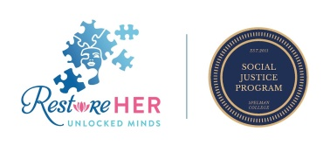
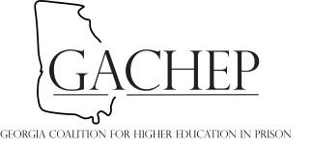
Beyondtheboxga.com

